Q6. Explain **== operator** and **equals()** method in java programming?

Ans:

== l meant for reference compare. If two object have a same reference then it will return true otherwise it will return false.

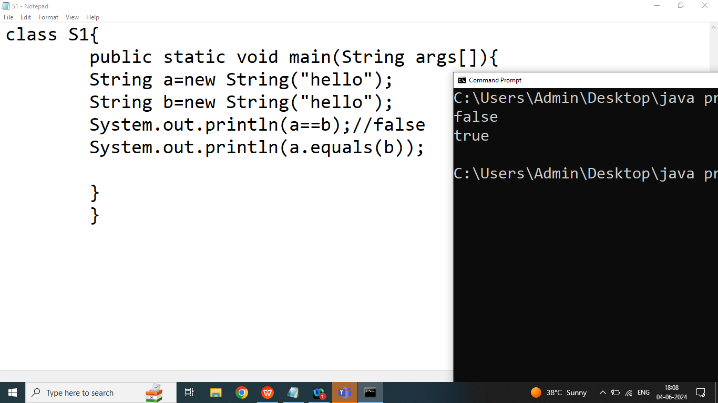

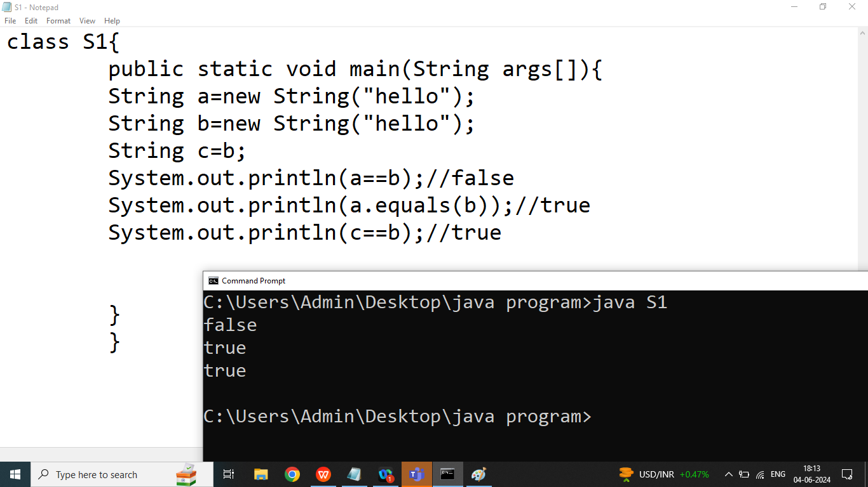

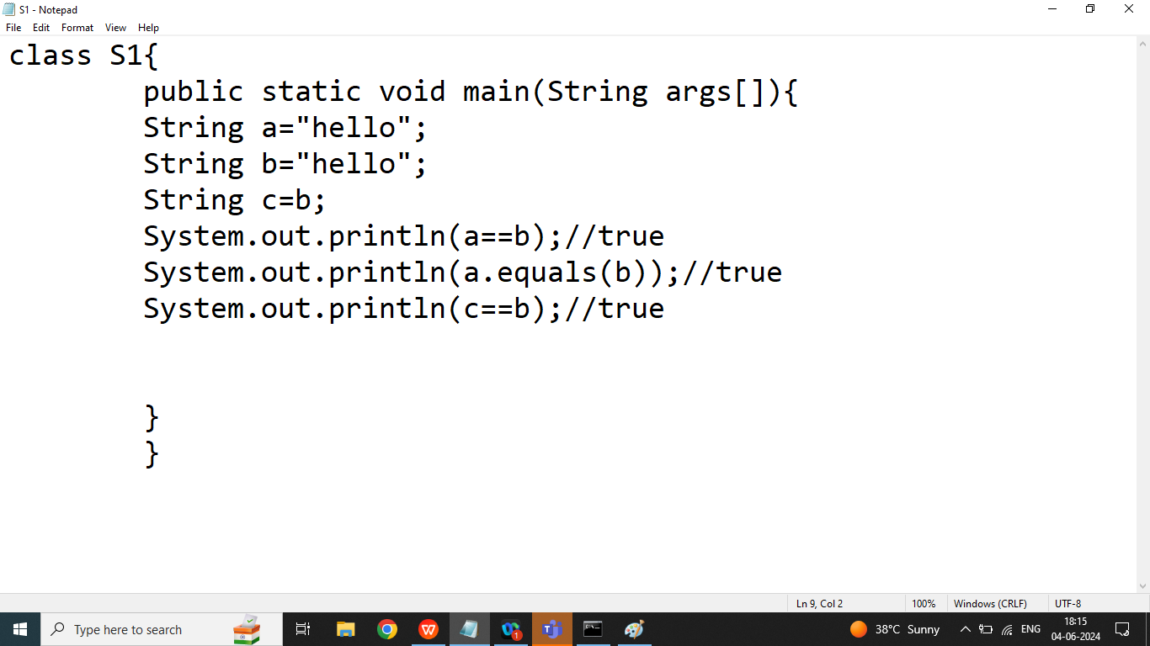

Q6,7. Explain String class **equals()** method and **equalsIgnoreCase()** method?

Ans:

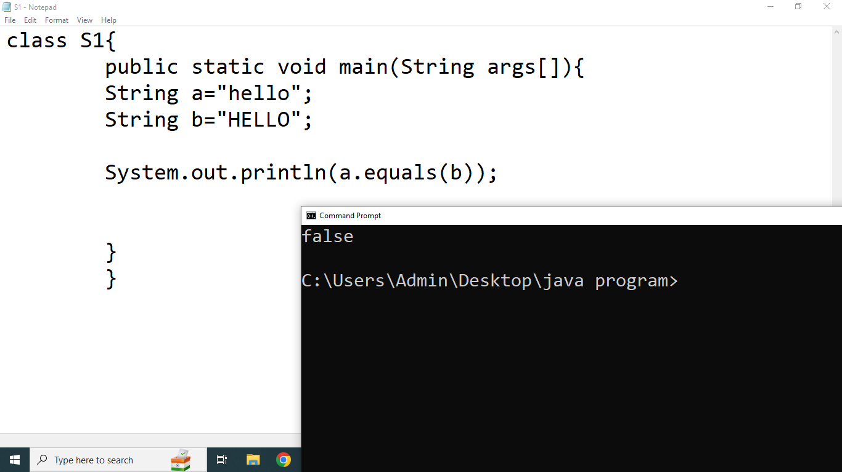

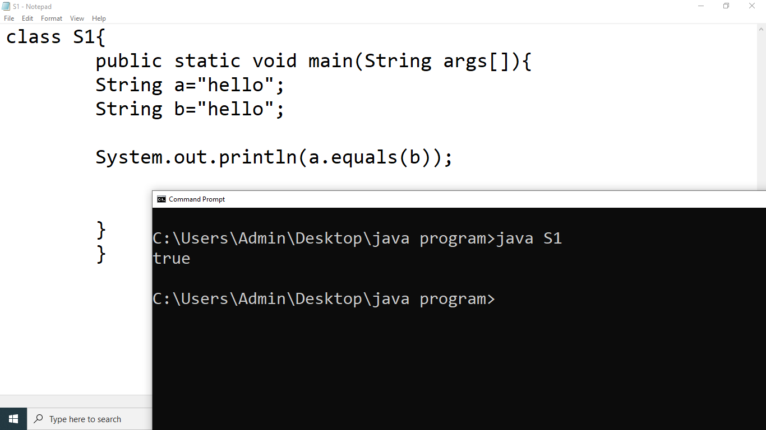

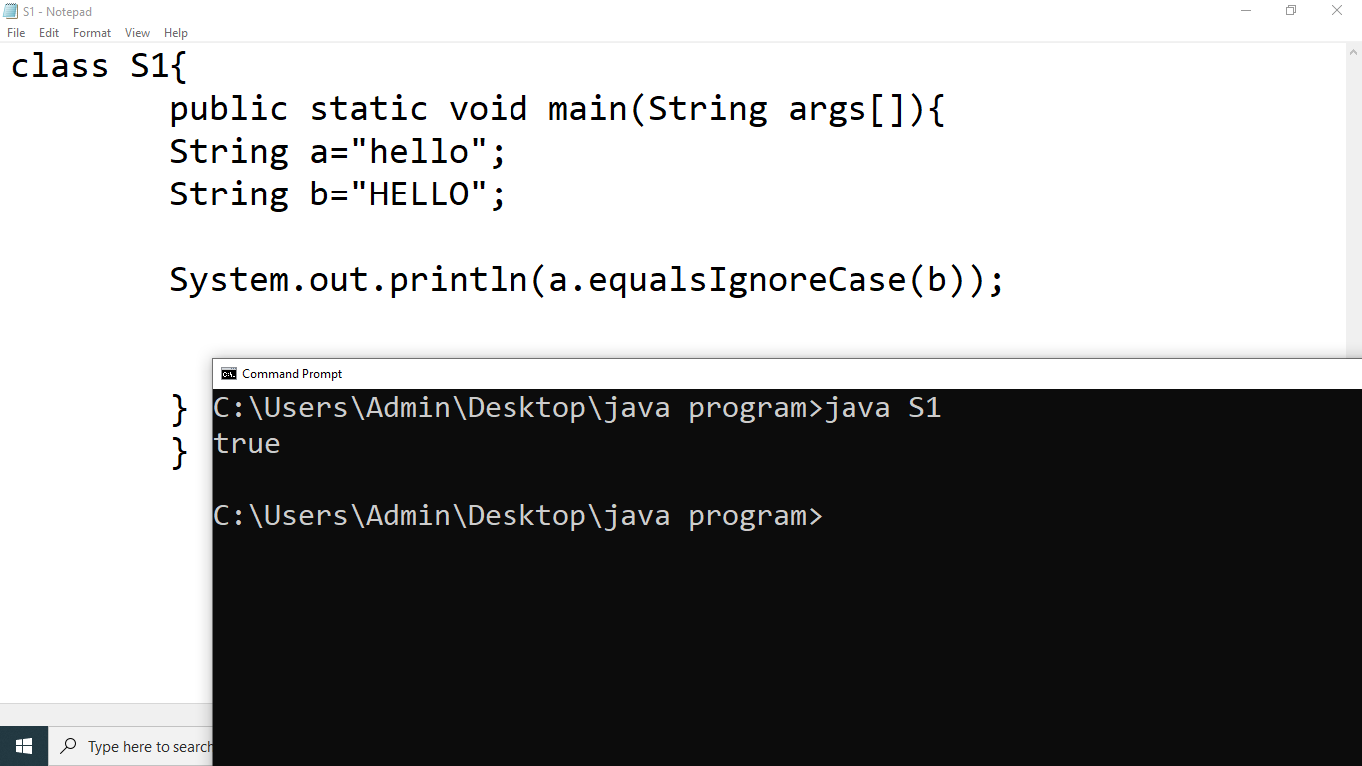

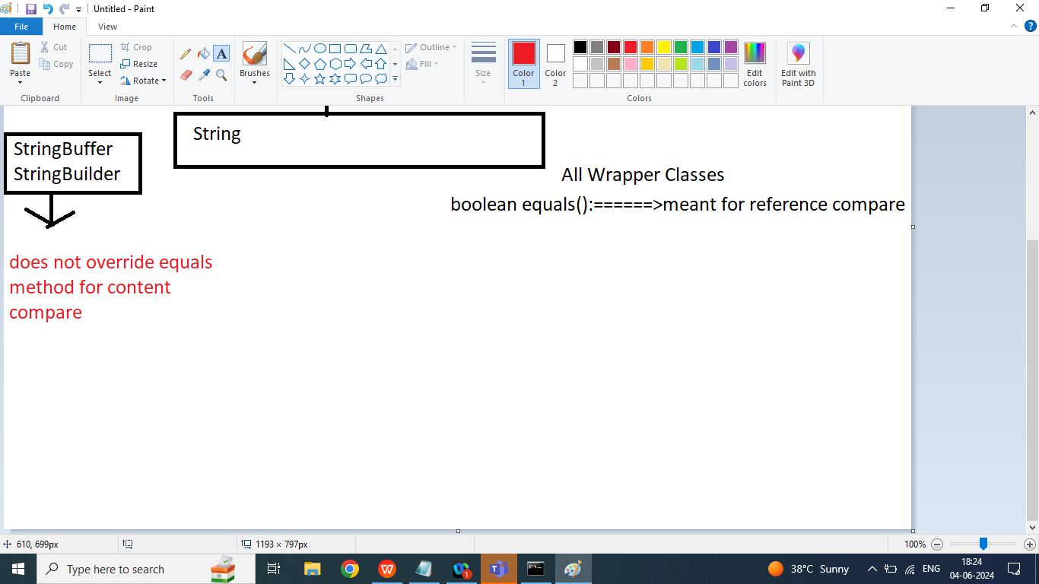

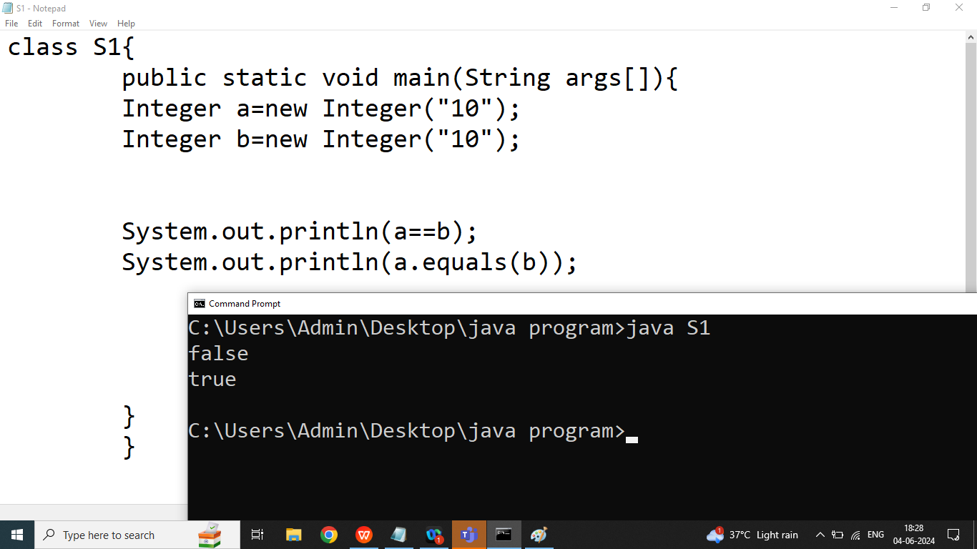

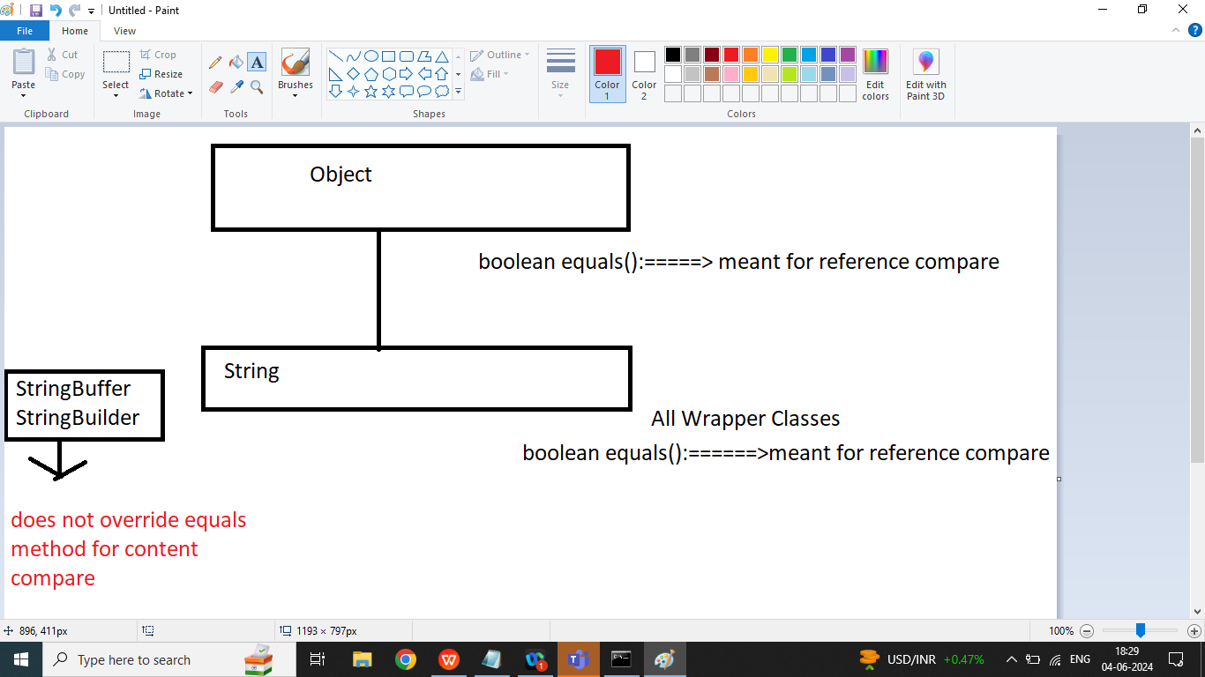

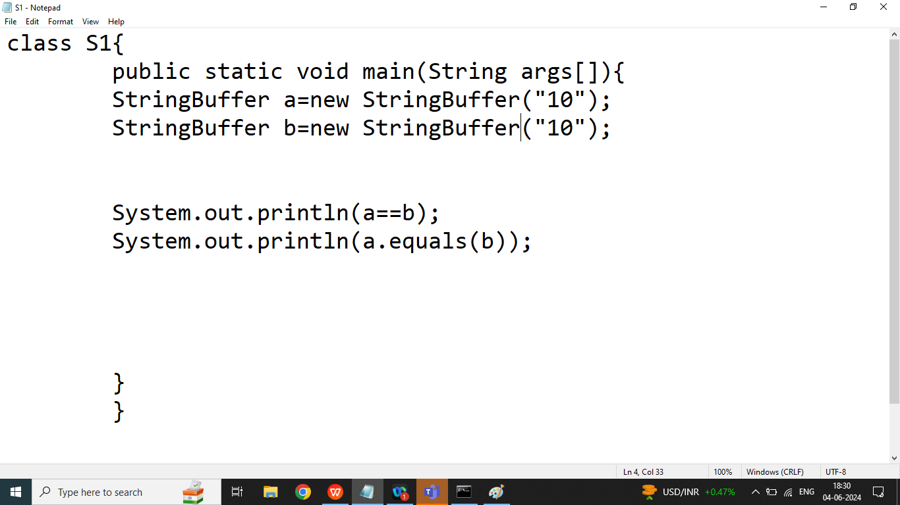

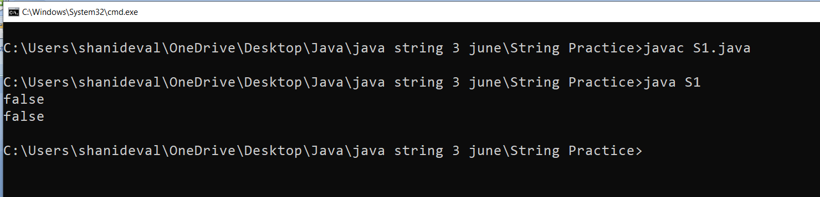

Q8.Explain String class **isEmpty()** method in java programming?

Ans:

It will return true if given String is empty otherwise it will return false.

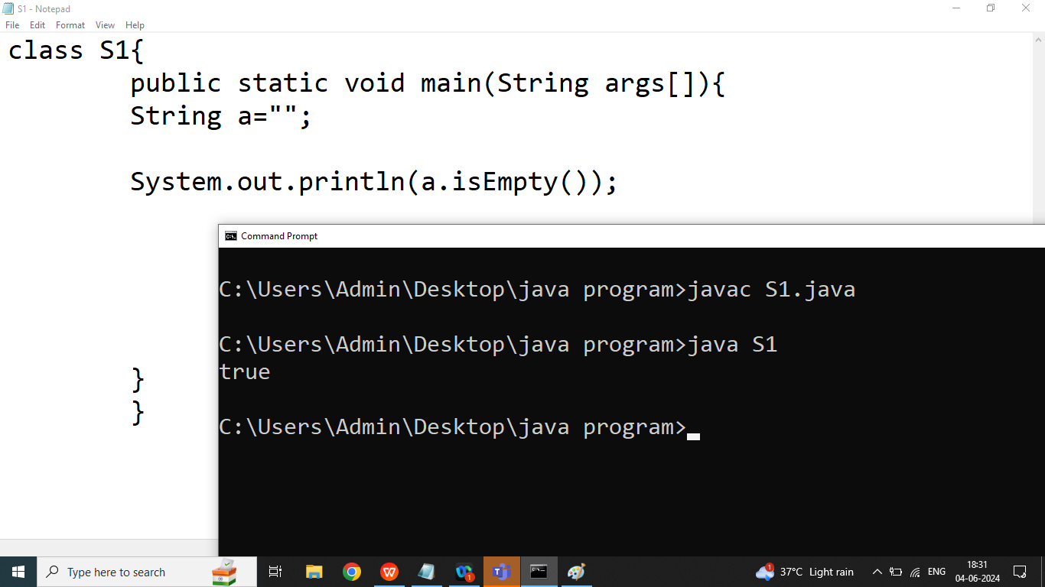

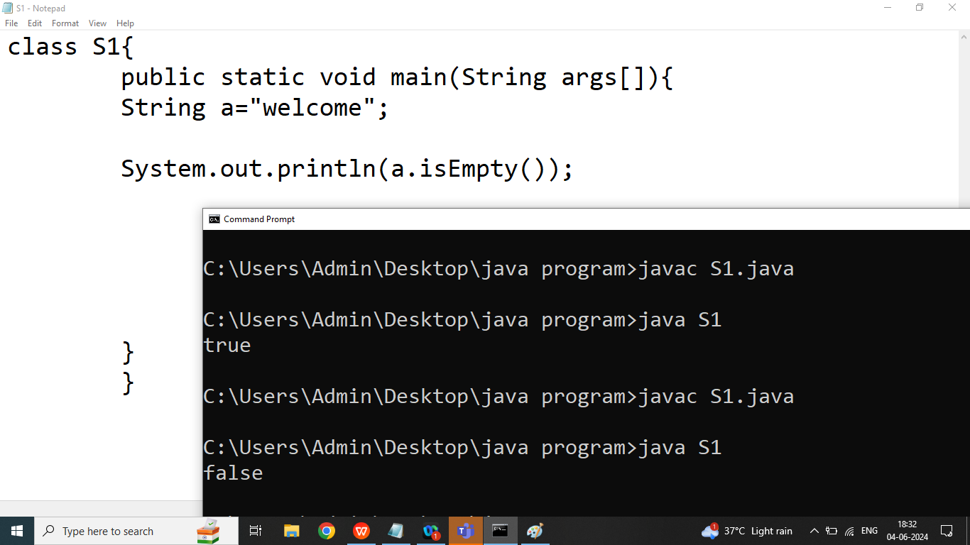

Q4. Explain String class **contains()**method in java programming?

Ans: Checks whether a String contains a sequence of character.

Syntax:

boolean contains(String);

Example:

String str=” Welcome to bhopal”;

Boolean b=str.contains(“to”);//true

Boolean x=str.contains(“java”);//false

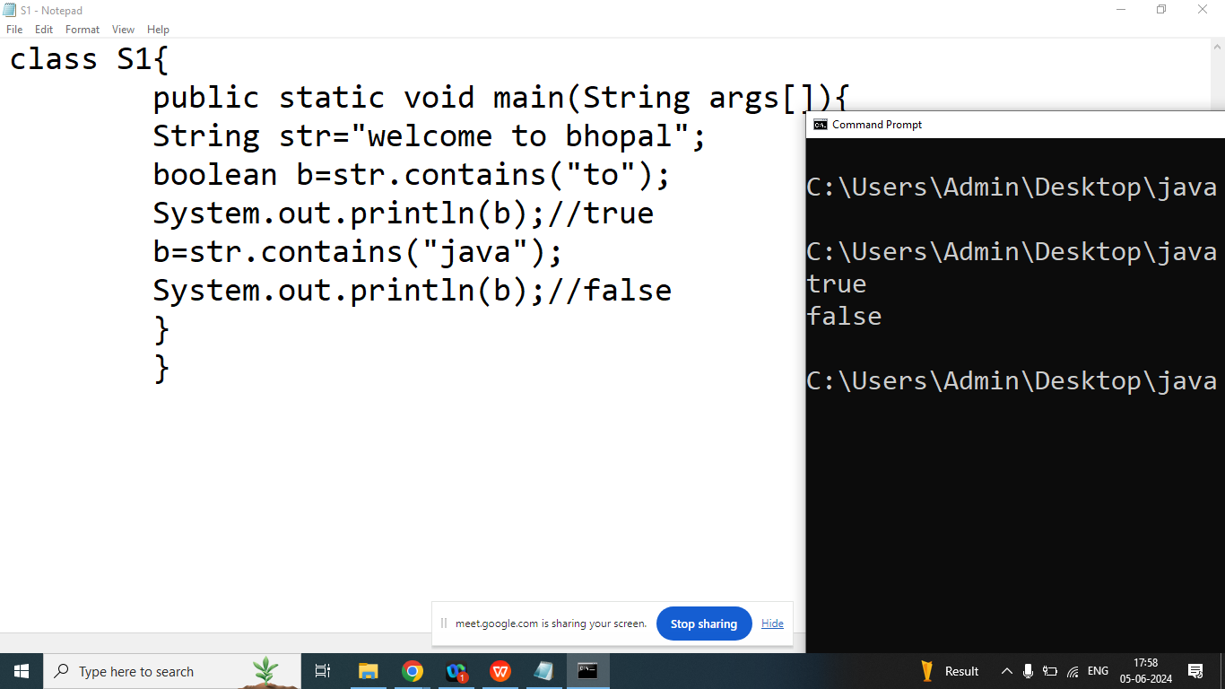

Q5. Explain String class **endsWith()** method in java programming?

Ans: Checks whether a String ends with the specified sequence of character.

It is used to check a String ends with a suffix

Syntax:

boolean endsWith();

Example:

String a=”www.cybrom.com”;

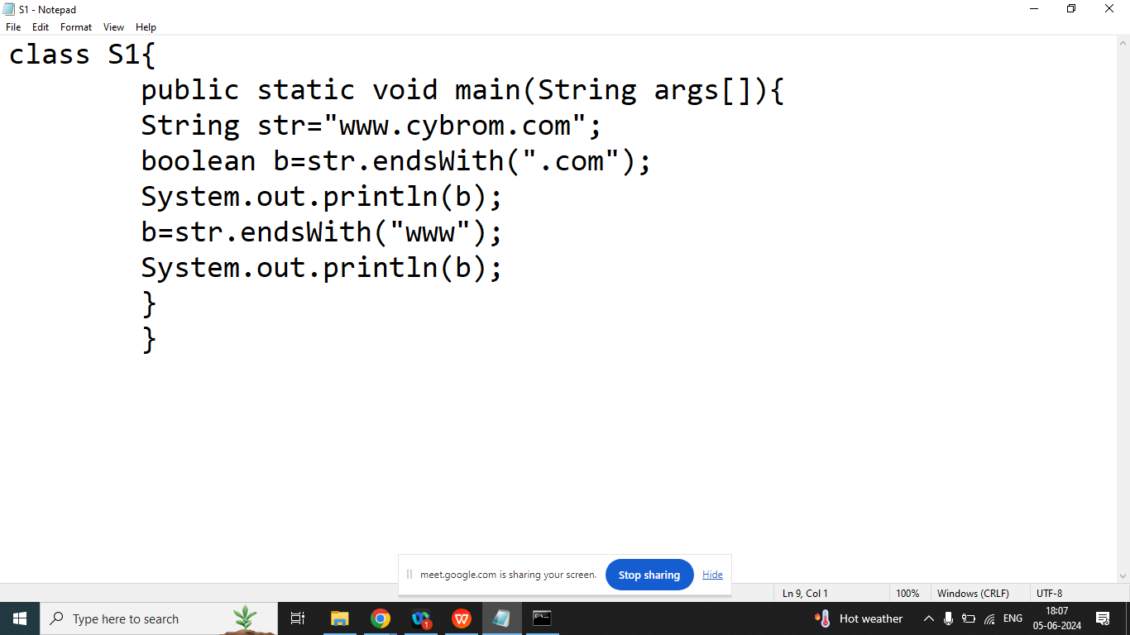

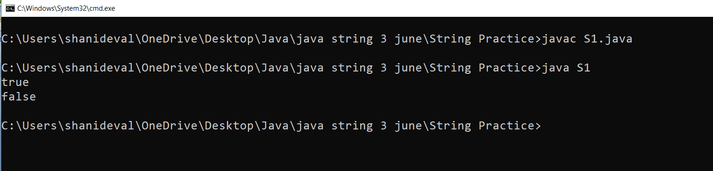

Q13. Explain String class **startsWith()** method in java programming?

Ans: Checks whether a String starts with the specified sequence of character.

It is used to check a String starts with a suffix

Syntax:

boolean startsWith();

Example:

String a=”www.cybrom.com”;

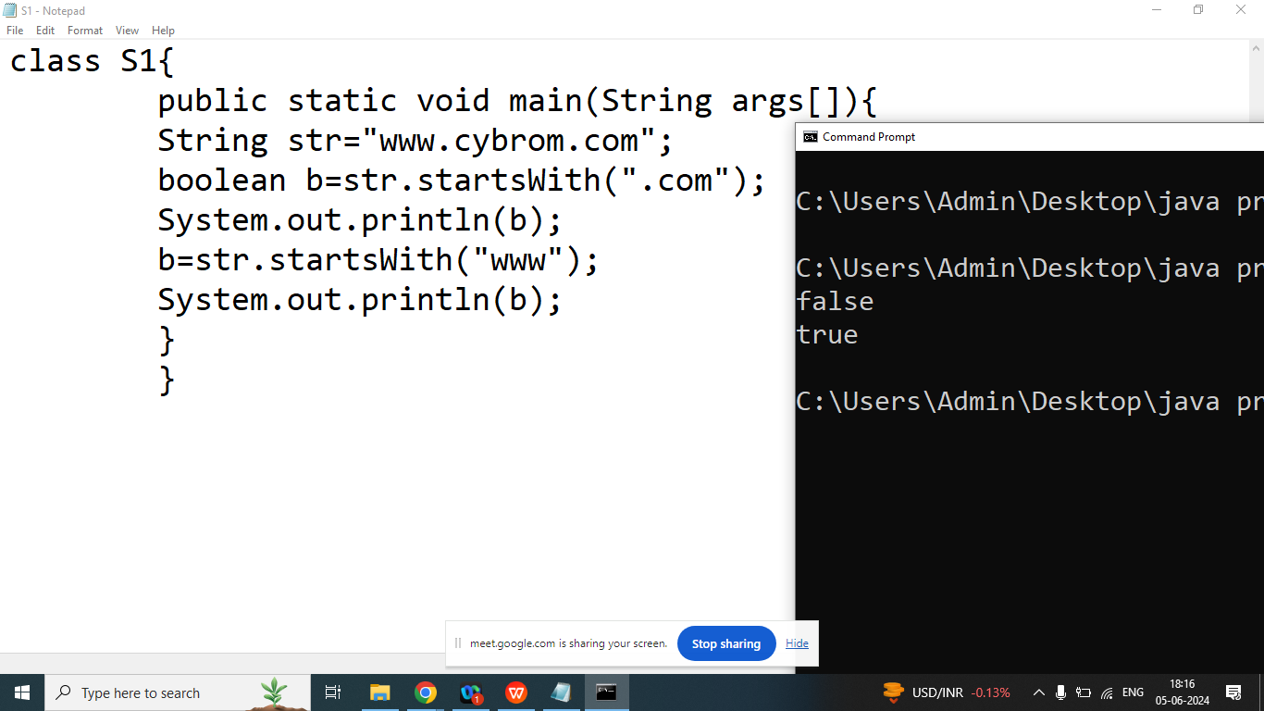

Q9.Explain String class **indexOf()** method in java programming?

Ans: Returns position of the first found occurrence of specified characters in a String.

If characters not found then it will return -1

Syntax:

public int indexOf(String);

public int indexOf(String,int position) ;

Example:

String str=”Welcome”;

|  |  |  |  |  |  |  |
| --- | --- | --- | --- | --- | --- | --- |
| W | e | l | c | o | m | e |
| 0 | 1 | 2 | 3 | 4 | 5 | 6 |

===================================>

int x=str.indexOf(“e”);//1

int y=str.indexOf(“e”,2);//6

int z=str.indexOf(“me”);//5

int k=str.indexOf(“Zee”);//-1

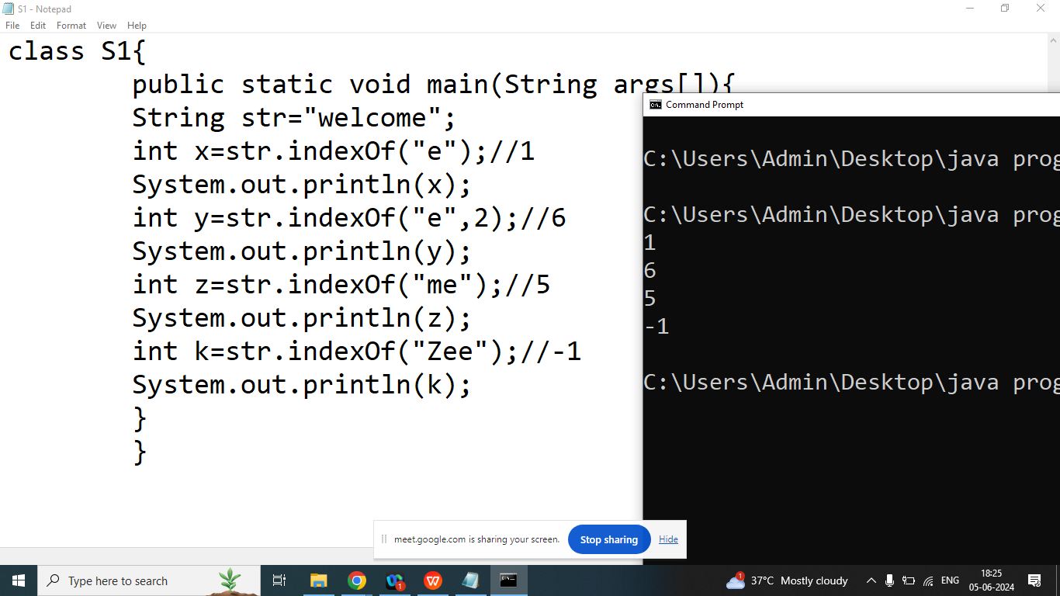

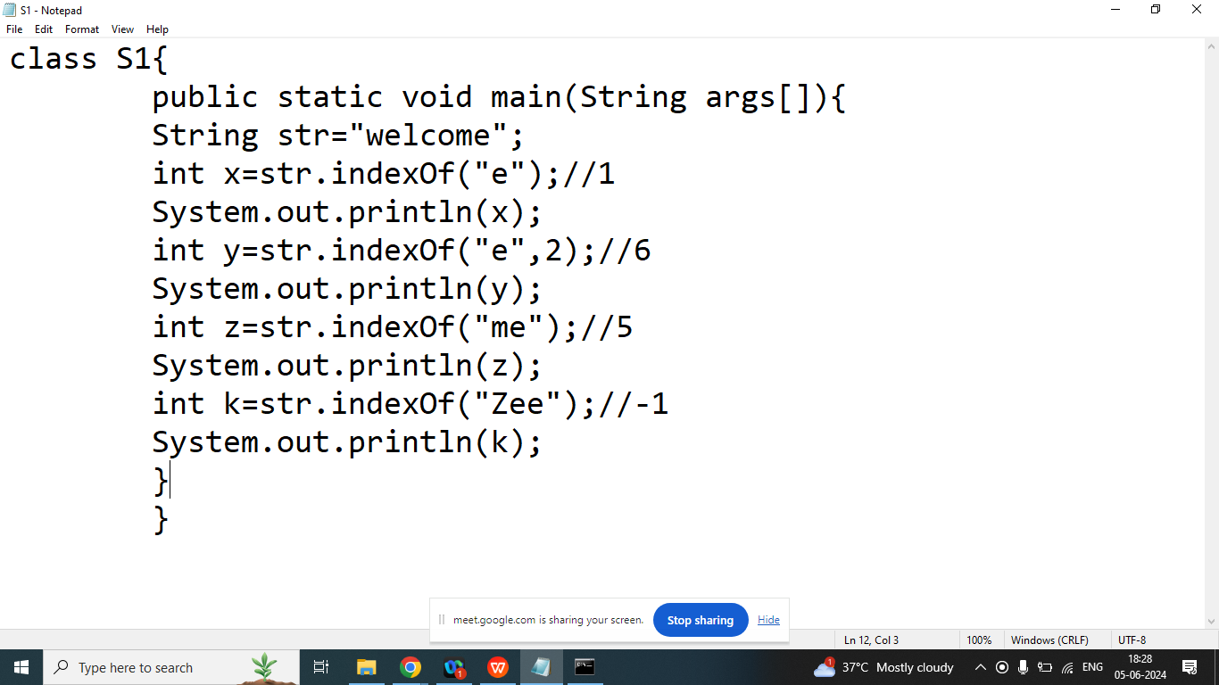

Q10.Explain String class **lastIndexOf()** method in java programming?

Ans: Returns position of the last found occurrence of specified characters in a String.

If characters not found then it will return -1

Syntax:

public int lastIndexOf(String);

public int lastIndexOf(String,int position) ;

Example:

String str=”Welcome”;

|  |  |  |  |  |  |  |
| --- | --- | --- | --- | --- | --- | --- |
| W | e | l | c | o | m | e |
| 0 | 1 | 2 | 3 | 4 | 5 | 6 |

<==============

int x=str.lastIndexOf(“e”);//6

int y=str.lastIndexOf(“e”,5);//1

int z=str.lastIndexOf(“me”);//5

int k=str.lastIndexOf(“Zee”);//-1

